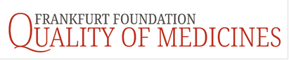
Focus on drug quality
Every day, medicinal products make a decisive contribution to curing diseases - especially serious ones - or alleviating ailments, extending the life expectancy of patients and improving their quality of life. In addition to high expectations in terms of the efficacy and safety of medicinal products, the quality of the medicinal products is also crucial in patient care.
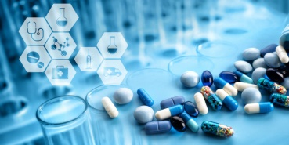
The non-profit Frankfurt Foundation Quality of Medicines (FFQM) is committed to promoting research activities that contribute to optimally safeguarding the quality of medicinal products in Germany and, if necessary, further optimizing them, even if they are manufactured outside the country. The central concern is the research of new processes as well as the implementation of innovative technologies and standardization approaches including the critical evaluation of already established concepts for quality assurance.
What is funded?
In accordance with the purpose of the foundation, the activities listed below are particularly promoted.
- Doctoral, diploma or seminar theses at universities as well as other scientific projects that deal with the optimization of existing quality assurance methods in the pharmaceutical sector, as well as the development of innovative processes and their implementation in practice
- Research work on drug quality as well as proof of the therapeutic interchangeability of generic medicinal products, above all through evidence of bioequivalence
- Congress trips in order to be able to present your own research results to improve the quality of medicinal products
- Investigations due to the quality of medicinal products on the market and their therapeutic interchangeability
- Activities to raise awareness of the importance of the quality of medicinal products in politics and the public.

Own initiatives to pursue the statutory purposes
The foundation also pursues its statutory objectives directly, in particular through
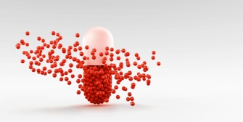
- warding prizes and / or awarding medals for research projects, publications or initiatives to promote drug quality and projects to demonstrate the interchangeability of generic medicinal products
- planning and organization of information and discussion events on drug quality as well as for the therapeutic interchangeability of generic medicinal products, e.g. seminars, expert meetings or press events
Cooperation with scientific societies
The foundation is well networked nationally and internationally. Cooperation agreements exist with
- The German Pharmaceutical Society (DPhG) on technical issues and research funding projects.
- The European Federation for Pharmaceutical Sciences (EUFEPS) about their Network on Bioavailability and Biopharmaceutics.
- The German Platform NanoBioMedicines
Donations and endowments
- A donation supports the supporting activities of the foundation and is used timely by the foundation for its statutory purposes.
- An endowment increases the assets of a foundation. This strengthens their performance in the long term.
Our non-profit foundation welcomes any support. Your donation or endowment is tax deductible.
Donation account: Frankfurt Foundation Quality of Medicines
IBAN: DE81 5022 0900 0002 2052 01
BIC: HAUK DEFF XXX
Contact details
Frankfurt Foundation Quality of Medicines
c/o Prof. Dr. Henning Blume
Westendstraße 61, 60325 Frankfurt/M
E-Mail: dagmar.walluf-blume@frankfurt-foundation.org
Telefon: 0171 – 2299381
https://frankfurt-foundation.org/

The Frankfurt Foundation Quality of Medicines (FFQM) is a legal foundation under civil law. It is recognized as a non-profit organization.

